Hash Map User Manual

By: Jacob Attia

## **1. What is this?**

This project shows how a very small hash map works. A hash map is a box that stores many items and lets you check quickly if an item is inside.

* We use a very simple hash rule: the length of the text (String.length()).
* Items that hash to the same value sit in a short list.
* The map grows when it gets too full.

## **2. What files are here?**

| File Name | Job |
| --- | --- |
| JacobHashMap.java | The main code for the map |
| JacobHashMapTest.java | A short test that adds a few words and prints results |
| HashMapExperiment.java | Makes lots of random words, times how long inserts take, and saves numbers to results.csv |

## **3. How does each file work?**

JacobHashMap.java

* Holds an array of LinkedLists. Each spot is called a bucket.
* dumbHash: length % bucketCount chooses the bucket.
* add(item): puts the item in the right bucket. If the map is 75 % full, it doubles the bucket count.
* contains(item): checks if the item is in its bucket.
* resize(newSize): makes a bigger (or smaller) bucket array and moves everything.

JacobHashMapTest.java

* Makes a map.
* Adds eight fruit names.
* Prints: does it have "banana"? does it have "kiwi"?
* Shows the bucket count before and after a manual resize to 32.

HashMapExperiment.java

* Builds maps of different sizes (10 k, 20 k, … 160 k words).
* Each word is 5–15 random letters.
* Tracks how long the insert loop takes.
* Writes one line per run to results.csv: size, timeInNanoseconds, bucketCount

## **4. Running the code and what you will see**

### **4.1 Compile everything**

### **4.2 Quick check of basic functions**

* java JacobHashMapTest
* You should see:

Contains 'banana'? true

Contains 'kiwi'? false

Initial capacity: 16

Capacity after manual resize: 32

* banana was added so it is found.
* kiwi was not added so it is not found.
* The map doubled its bucket array from 8 to 16 when it got 75 % full, then you resized it to 32 by hand.

### **4.3 Performance experiment**

* java HashMapExperiment
* This program makes new maps of different sizes, fills them with random words, times each fill, and saves the numbers to results.csv. Console example:
* 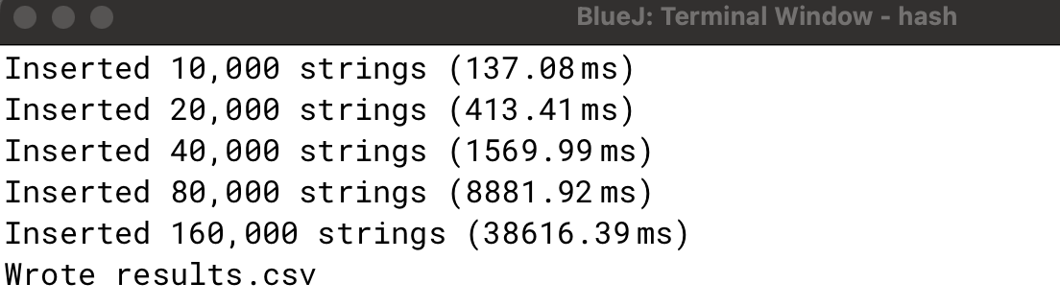
* Results.csv
* 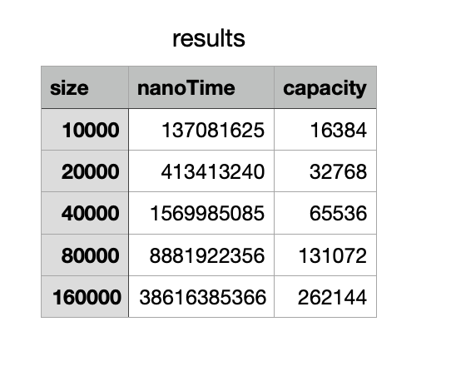

## **5. Conclusion**

This mini‑project shows how a hash map works at its core:

* Buckets hold items that hash to the same spot.
* A hash rule turns a key into a bucket number. We used key length so you can see collisions easily.
* When the map gets too full, it grows and every key is placed into a new bucket.

By running the simple test you see that look‑ups are quick. By running the experiment you see that insert time grows roughly in a straight line and that bucket size doubles at certain points.

Use this code as a starting point to try better hash rules, add a remove() method, or compare with Java’s built‑in HashSet. Each change will teach you a bit more about how real hash maps balance speed and memory.